Quarterly Report – Public Page

Date of Report: 10th Quarterly Report- March 28, 2025
Contract Number: 693JK32210002POTA
Prepared for: Government Agency: DOT and Co-funders
Project Title: Monitoring the Long-Term Compatibility of Vapor Corrosion Inhibitor and Cathodic Protection Associated Components
Prepared by: Pipeline Research Council International, Inc.
Contact Information: Janie Norton, email: jnorton@prci.org
For quarterly period ending: March 31, 2025

1: Items Completed During this Quarterly Period:

Item # | Task # | Activity/Deliverable | Title | Federal Cost | Cost Share
33 | 2 | Finish field testing for the tanks pre-treated with VCIs, collect coupons and ER probe data, analyze corrosion rate data | Summary of findings to be included in quarterly report | $19,545 | $19,545
34 | 3 | Monitor progress of the VCI plus CP compatibility issue field data collection | Summary of the progress to be included in quarterly report | $6,515 | $6,515
35 | 5 | Quarterly status report & project management | Submit 10th quarterly report | $4,249 | $4,249

2: Items Not Completed During this Quarterly Period:

Item # | Task # | Activity/Deliverable | Title | Federal Cost | Cost Share
30 | 2 | Finish large-scale control experiments to determine VCI dispersion range, collect and analyze data | Summary of the data to be included in the quarterly report | $19,545 | $19,545

3: Project Financial Tracking During this Quarterly Period:

Note that this chart reflects Federal share only.
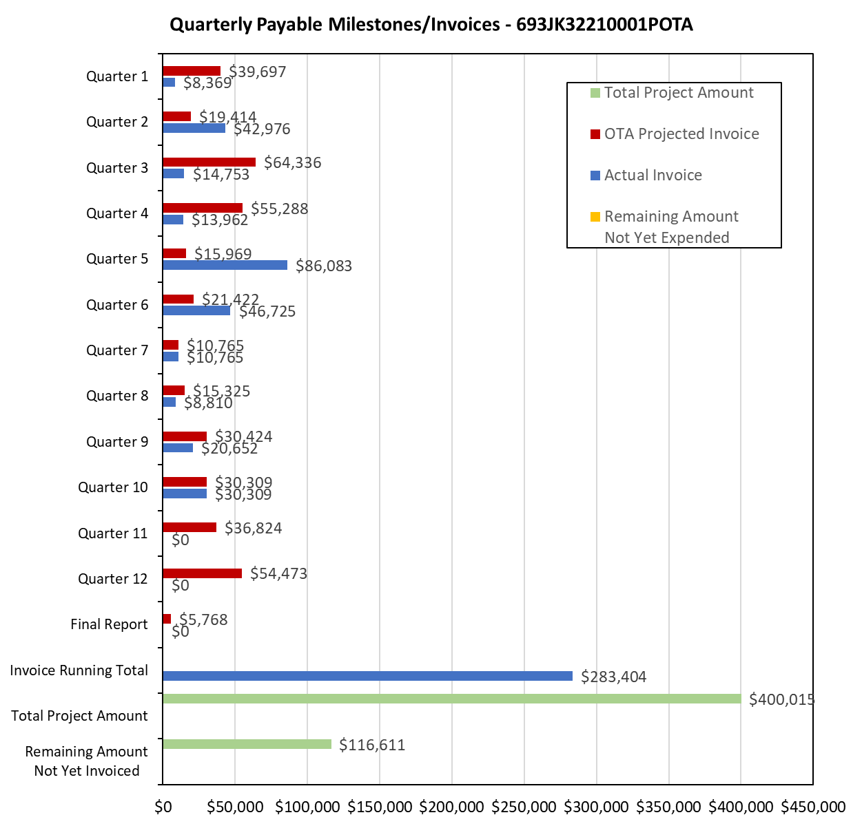

4: Project Technical Status:

Item 33, Task 2 ⎯ Finish field testing for the tanks pre-treated with VCIs, collect coupons and ER probe data, analyze corrosion rate data. Summary of the data to be included in the quarterly report: The coupon and ER probe data is summarized in Table 1 below.

Table 1. Mass-Loss Coupon, ER and UT Probe Derived Corrosion Rates for the VCI Treated Tanks
Tank Number | Approximate Age of VCI Application | Coupon Corrosion Rate (mpy) |  | ER/UT probe Corrosion rate (mpy)
Tank Number | Approximate Age of VCI Application | Unbonded | Bonded | ER/UT probe Corrosion rate (mpy)
1 | 3 | 0.03 | 0.02 | 0
2 | 4 | 0.1 and 7.9 | 0.01 and 5.3 | 0
3 | 3 | 0.2 and 0.5 | 0.4 and 0.7 | 0
4 | 3 | 0.04 and 0.5 | 0.02 and 0.1 | 0
5 | 3 | 0.8 and 4.5 | 1.3 and 2.1 | 0
6 | 4 | 0.14 and 0.38 | 0.4 and 0.5 | 0
7 | 2 | 0.05 and 0.08 | 0.03 and 0.02 | 0.2 to 0.7
8 | 3 | <0.01 | 0.1 and 0.3 | 0 to 0.2
9 | 3 | 0.01 and 0.04 | 1.2 and 2.6 | 0 to 0.5
10 | 5 |  |  | 0 to 0.8
11 | 5 |  |  | 1.2
12 | 5 |  |  | 0.2 to 1.0
13 | 7 | 0.9 and 2.6 | 0.4 and 2.5 | 0 to 1.2
14 | 6 | 0.6 and 3.6 | 1.4 and 1.4 | 0 to 0.2
15 | 2 | 0.4 and 0.6 | 0.4 and 2.2 | 0.5 to 5
16 | 2 | 0.84 | 0.04 | 1.2 to 10.9
17 | 10 | 0.3 | 0.5 | 0 to 0.5
18 | 10 |  |  | 0.3 to 1.1
19 | 10 | 1.2 | 1.5 | 0.5 to 3.5
20 | 8 | 1.0 | 0.8 | 0 to 0.5
21 | 8 | 0.25 | 0.2 | 0 to 0.2
22 | 2 |  |  | 0
23 | 1 |  |  | Questionable data
24 | 8 |  |  | Insufficient data
25 | 1 |  |  | Insufficient data

Following points are made from the data listed in Table 1:
- Mass-loss coupons were instated on 17 tanks, and for 14 tanks, the mass-loss coupons’ corrosion rates are similar to the ER/UT probe corrosion rates.
- For three tanks, the mass-loss and coupon corrosion rate data significantly differ from each other.
- Both bonded and unbonded coupons mass-loss derived corrosion rate data is similar.
- For most of the VCI treated tanks, the coupon corrosion rates are below 1 mpy, the meeting the corrosion protection requirement in NACE SP0169.

This activity links to items 6 and 7 as listed in Attachment 1 Team Project Activities. This activity also satisfies item 21 in Attachment 2 Project Deliverables.

Item 34, Task 3 ⎯ Monitor progress of the various field testing. Summary of the progress to be included in quarterly report: The field testing for the VCI-treated tanks and recently-VCI-treated tanks was started in the 5th quarter. The monitoring data for two quarters have been collected for those tanks. The field sand samples from the previously treated VCI tanks have been received and analyzed. The field sand samples from the recently-treated-with-VCI tanks have also been received and have been analyzed. The mass-loss coupons that were placed under some of the VCI treated tanks were removed. The mass-loss coupons have been analyzed. In addition, the monitoring data for electrical resistance (ER) and UT probes were collected during the seventh quarter; the eight quarter readings were collected in October 2024, and the ninth quarter reading were collected in December 2024, and the 10th quarter ER probe reading will be collected in April 2025. Year 2024 Q3 inspections were missed due to the storage terminal maintenance. In addition, the project team was able to collect ER probe data form approximately 30 additional tanks. This activity links to items 6 and 7 as listed in Attachment 1 Team Project Activities. This activity also satisfies item 20 in Attachment 2 Project Deliverables.

Item 35, Task 5 ⎯ Quarterly status report & project management. Submit 10th quarterly report: The 10th quarter project meeting was held on March 19, 2025. This item has been completed, and it partly satisfies item 25 in Attachment 2 Project Deliverables. It also links to item 13 as listed in Attachment 1 Team Project Activities. The quarterly meeting link to item 11 as listed in Attachment 1 Team Project Activities.

5: Project Schedule:

Item 30, Task 2 ⎯ Finish large-scale control experiments to determine VCI dispersion range, collect and analyze data. Summary of the data to be included in the quarterly report: Of the two large-scale experiments, one is still on-going. The second large-scale experiment will be finished in the next quarter. The post-VCI treated coupons will be extracted and analyzed.

Overall, the project is behind schedule, a six-month no-cost extension will be sought.

